A CRM APPLICATION FOR THECHAISHOP&CO
3. Project Design Phase

Project & Team Details
Attribute | Details
Project Title | A CRM Application for TheChaiShop&Co
Domain | Cloud Computing / Salesforce Administration
Platform | Salesforce Lightning Developer Edition
Institution | PS PT MGR Government Arts & Science College, Sirkali, Puthur - 609108 (College Code: ANM403)
Submission Portal | SkillWallet
Team Leader | PRITHIVIRAJ R - (Reg. No. 24134031802521033)
Member 2 | Dharun Mass - (Reg. No. 24134031802521016)
Member 3 | Ajan A - (Reg. No. 24134031802521006)
Member 4 | Sanjai D - (Reg. No. 24134031802521041)
Member 5 | Vigneswaran C - (Reg. No. 24134031802521055)

3. PROJECT DESIGN PHASE

3.1 Problem-Solution Fit
The CRM system replaces manual paper-based logs and fragmented spreadsheets with automated, centralized data management on the Salesforce Cloud platform. Cloud storage prevents accidental data loss, declarative formula fields eliminate billing calculation errors, scheduled background flows handle customer birthday communications, and interactive dashboards remove reporting delays to deliver timely business insights.

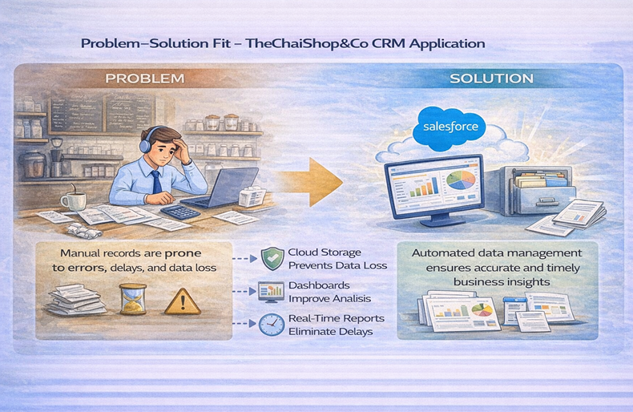

3.2 Proposed Solution & Capabilities
Capability | Technical Description
User Login & Authentication | Allows authorized counter clerks and managers to securely access the CRM using Salesforce credentials.
Customer Record Management | Supports creating, viewing, and updating retail customer details including name, phone number, and birth date.
Enterprise Management | Manages corporate client accounts and bulk procurement partnerships (e.g., Infosys, TCS, Wipro).
Employer Management | Stores store staff and management data, tracking roles, designations, and identity parameters.
Order Management | Facilitates order entry and categorizes transactions using distinct Record Types (Online Order vs. Walk-In Order).
Automated Billing System | Computes order quantity and total payable bill dynamically using declarative formula logic.
Validation Rules | Enforces format consistency by verifying mandatory fields and requiring 10-digit numeric phone numbers.
Record Types & Page Layouts | Displays channel-specific form fields tailored for walk-in counter orders or online delivery dispatches.
Global Picklists | Maintains standardized picklist sets across objects for Gender, Items, Payment Mode, and Type of Items.
Email Notification System | Dispatches personalized birthday greeting emails featuring promo discount code [HBDAY50].
Workflow & Flow Automation | Executes daily schedule-triggered evaluations at 12:00 AM without requiring manual staff intervention.
Report Generation | Summarizes sales metrics grouped by Record Type and product category.
Dashboard Visualization | Visualizes live retail volume and corporate revenue distribution using interactive Bar and Donut charts.

3.3 Solution Architecture (4-Layer Modular Design)
The application follows a structured, enterprise-grade multi-layer architecture to ensure scalability and maintainability:
Layer | Description
Presentation Layer (Lightning UI) | Custom Lightning App (TheChaiShop&Co), Custom Tabs, Record Types, and Page Layouts providing a modern, responsive user experience.
Application Layer (Flows & Logic) | Declarative validation engines, formula calculation logic, schedule-triggered background flows, and workflow email alerts.
Data Layer (Custom Objects) | Relational schema consisting of Customer_Account__c, Enterprise_Account__c, and Employer_Account__c linked through Lookup relationships.
Analytics Layer (Reports & Dashboards) | Built-in reporting engines generating grouped summary reports and interactive side-by-side executive dashboards.

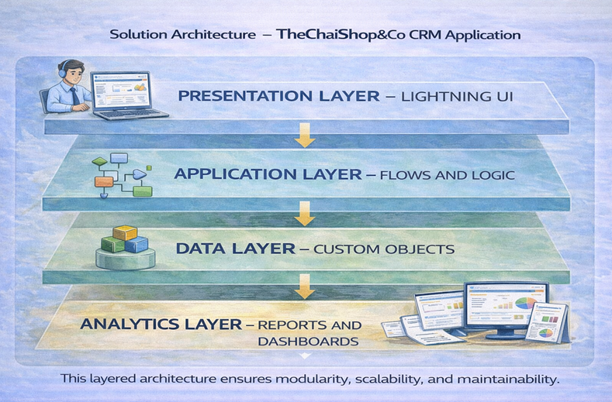

3.4 Data Schema & Entity Specifications
1. Customer Account (Customer_Account__c)
Field / Category | Specification
Standard Field | Customer Account Name (Data Type: Text)
Contact Fields | First_Name__c (Text, 25, Required); Last_Name__c (Text, 25, Required); Phone_Number__c (Phone, Required); Email_ID__c (Email, Required); Address__c (Text, 125).
Demographics | Gender__c (Picklist, Global Set: Gender); Date_of_Birth__c (Date, Required).
Relationship | Associated_Employer__c (Lookup Relationship to Employer_Account__c).
Product & Pricing | Type_of_Items__c (Multi-Select Picklist); Products_purchased__c (Multi-Select Picklist); Chai__c (Multi-Select Picklist); Payment_Mode__c (Picklist).
Automated Logic | Date_of_Birthday_is_today__c (Formula Checkbox); Order_Quantity__c (Formula Number); Total_Bill__c (Formula Number).

2. Enterprise Account (Enterprise_Account__c)
Field / Category | Specification
Standard Field | Enterprise Account Name (Data Type: Text)
Business Fields | Enterprise_Name__c (Text, 25, Required); Phone_Number__c (Phone, Required); Email_ID__c (Email, Required); Address__c (Text, 125).
Procurement | Type_of_Items__c (Multi-Select Picklist); Products_purchased__c (Multi-Select Picklist); Payment_Mode__c (Picklist).
Relationship | Associated_Employer__c (Lookup Relationship to Employer_Account__c).
Automated Logic | Order_Quantity__c (Formula Number); Total_Bill__c (Formula Number).

3. Employer Account (Employer_Account__c)
Field / Category | Specification
Standard Field | Employer Account Name (Data Type: Text)
Employee Details | First_Name__c (Text, 25, Required); Last_Name__c (Text, 25, Required); Gender__c (Picklist); Date_of_Birth__c (Date, Required).
Employment & Tax | Designation__c (Picklist); Salary__c (Currency); Phone_Number__c (Phone, Required); Email_ID__c (Email, Required); PAN_Details__c (Text, 10); Aadhar_Number__c (Text, 12).

